**Submission Form**

**Fill up the following slots with appropriate content. You must submit the content of this document from this page only.**

1. Your Name: Shihab Muhtasim
2. Your ID: 21301610
3. Your Section: 8
4. Experiment No: 2
5. Experiment Title: To verify Ohm’s Law
6. **You must write your ID in each of the graphs you insert here.**
7. **Data Table 1**:

$R_{1 }=776 Ω$

| **Sl:** | **Voltage, V (volt)** | **Electric Current, I (mA)** |
| --- | --- | --- |
| 1. | 2 | 2.6 |
| 2. | 3 | 3.9 |
| 3. | 4 | 5.2 |
| 4 | 5 | 6.4 |
| 5 | 6 | 7.7 |
| 6. | 7 | 9.0 |
| 7. | 8 | 10.3 |
| 8. | 9 | 11.5 |

1. **Data Table 2:**

$R_{2 }=707 Ω$

| **Sl:** | **Voltage, V (volt)** | **Electric Current, I (mA)** |
| --- | --- | --- |
| 1. | 2 | 2.8 |
| 2. | 3 | 4.2 |
| 3. | 4 | 5.7 |
| 4 | 5 | 7.1 |
| 5 | 6 | 8.5 |
| 6. | 7 | 9.9 |
| 7. | 8 | 11.3 |
| 8. | 9 | 12.7 |

1. **Data Table 3:**

$V=3.9 volt$

| **Sl:** | **Resistance, R (Ω)** | **Electric Current, I (mA)** |
| --- | --- | --- |
| 1. | 100 | 39 |
| 2. | 200 | 19.5 |
| 3. | 300 | 13 |
| 4 | 400 | 9.8 |
| 5 | 500 | 7.8 |
| 6. | 600 | 6.5 |
| 7. | 700 | 5.6 |
| 8. | 800 | 4.9 |

1. Draw I vs V graph for Data Table 1 and 2, that is you plot V along the $x$-axis and I along the $y$-axis. You should label the axes accordingly. For two tables you will get two straight lines. You can either draw both the lines in the same graph or use two graphs; one for each table. You must label the lines such that we can identify the lines corresponding to the tables. Insert the **graph /graphs** here:

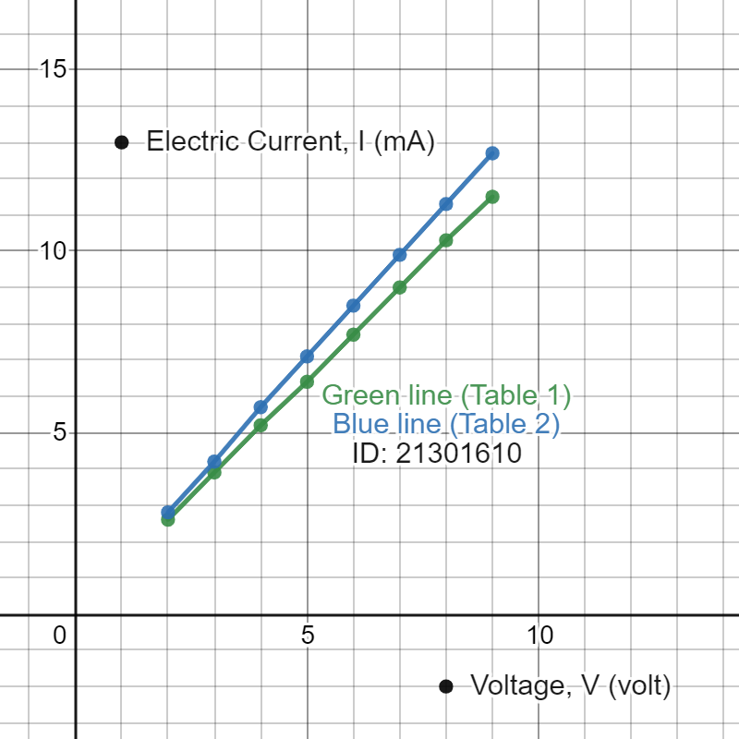

1. For Data Table 1,

Slope = 1.27381 mA/V

Calculated Resistance, R`_1 = (1/1.27381)*1000 Ω = 785.046 Ω

Percentage of error

= [ (Calculated Resistance - Given Resistance **)** / Given Resistance ] * 100

= [ (R`_1- R_1) / R_1 ] * 100

= [ (785.046- 776) / 776 ] * 100

= 1.165 %

For Data Table 2,

Slope = 1.41429 mA/V

Calculated Resistance, R`_2 =(1/1.41429)*1000 Ω = 707.068 Ω  
  
Percentage of error

= [ **(** Calculated Resistance - Given Resistance **)** / Given Resistance ] * 100

= [ **(** R`_2 - R_2 **)** / R_2 ] * 100

= [(707.068-707 )/707]*100

= 0.00961%

[Note percentage of error can be negative].

1. Draw I vs R graph for Data Table 3, that is you plot R along x-axis and I along y-axis. You should label the axes accordingly. Insert **graph-3** here:

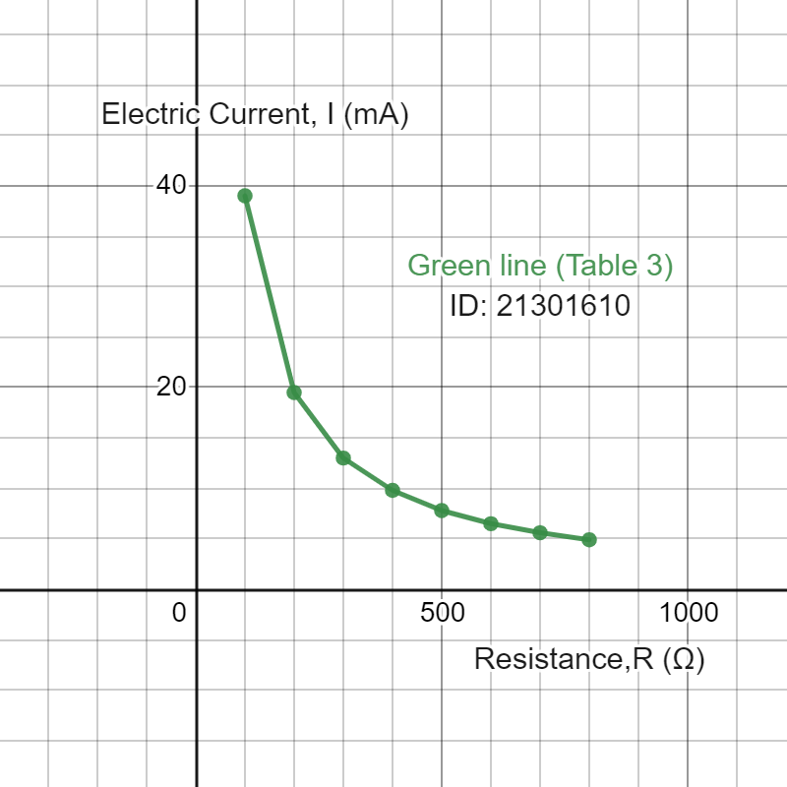

You are ***strongly*** encouraged to use your **own words** to describe your thoughts. **However, any kind of plagiarism (such as copying from other students’ lab-reports) will not be tolerated and will be subject to disciplinary action according to BracU policy.**

Please briefly answer the following questions:

1. Explain the graph you see in step 12. [Hint: (i) What kind of function does the curve represent? (ii) How does it relate to Ohm’s law?]  
     
   In step 12, I see a hyperbolic graph. It is an I vs R graph where I is inversely proportional to 1/R , R being the resistance and I as the flow of electricity. If the resistance in an object is higher , the electricity flow will be low and if the resistance in an object is lower then, the electricity flow will be high. According to Ohm’s law we know that the resistance is inversely proportional to the electric current and the graph in step 12 relates to this law.
2. What assumption do you have to make about the temperature for Ohm’s law to hold true? [ Write the assumption in one line. ]

We know, temperature is directly proportional to resistance when the length and width of the material is constant so as long as the temperature (T) stays constant, Ohm’s law will be true because the characteristics of Ohm’s law such that resistance (R) of an object through which electricity flow is hindered with the change of the temperature. Therefore, we can say that temperature is proportional to electricity voltage and electricity flow.

Assumption: Temperature is constant if ohm's law holds true.

1. Sketch **I-V** graphs for the following cases and identify which graph corresponds to which type of material?   
   a. Resistance increases linearly with temperature:

Comment: Conductors are represented as resistance that increases linearly with temperature.

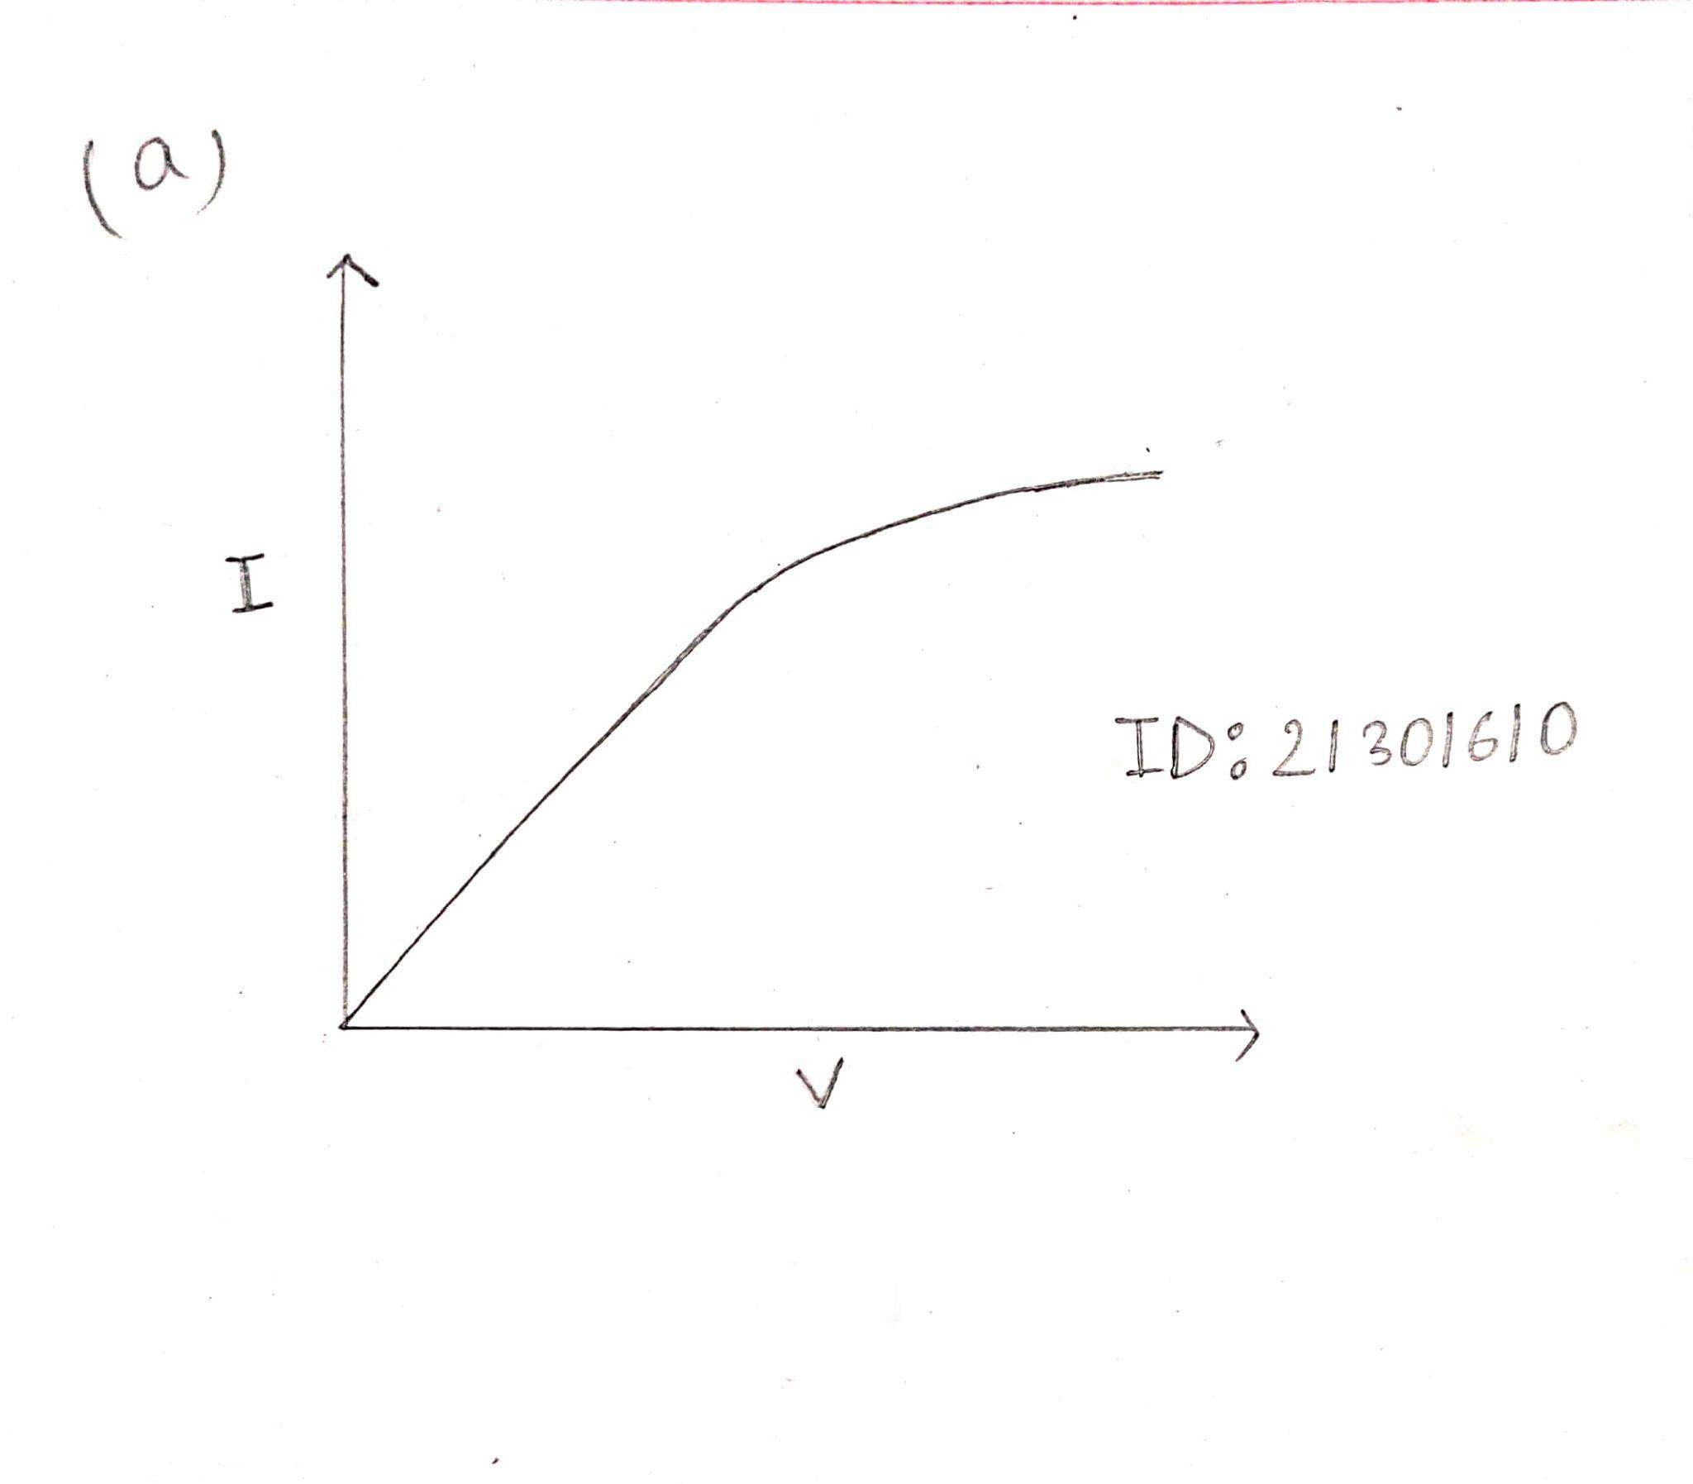

Graph: Conductor material

b. Resistance decreases inversely with temperature:

Comment: Semiconductors are represented as resistance that decreases linearly with temperature.

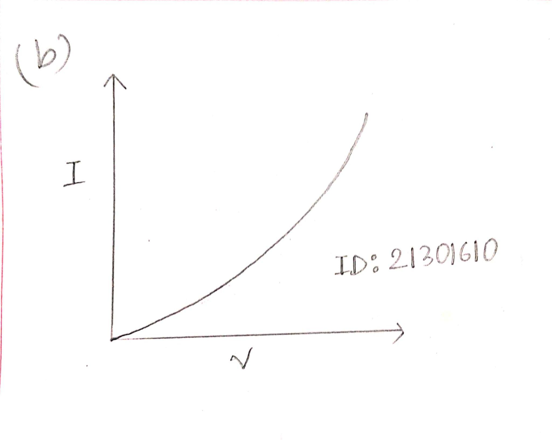

Graph: Semiconductor material

( Hint: You may ask yourself the question - Is this the graph for a Conductor/Semiconductor/Superconductor/Insulator?)  
  
You can either plot both the cases in the same graph or use two graphs; one for each case. Insert the graph/graphs here with the comment on the graph representing which material type. The comment should be precise and concise.